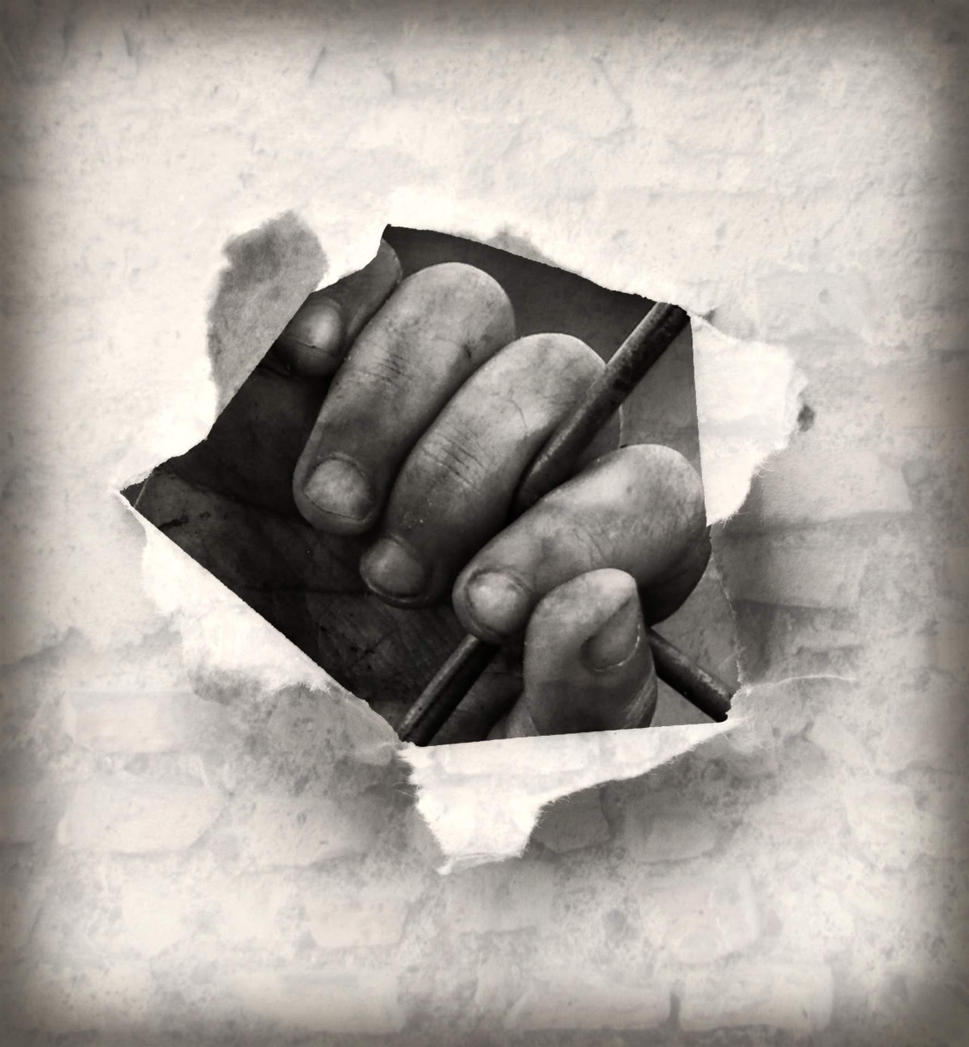
A Freedom Prayer
By Major John Read

Creator God, for freedom You made us.
In Your image and likeness You created us,
Free to love and be loved.
We pray against all powers and people that conspire to destroy your children’s freedom, trap them in poverty, steal their power and render them vulnerable to systems and schemes which make them slaves.

We pray for leaders and legislators, activists and agitators, and people of compassion everywhere, that they be strong and effective in their plans and actions to protect the vulnerable and secure their freedom.

Savior God,
For freedom You have redeemed us,
To be restored in Your image and likeness,
Free to love and be loved.
We pray for children, women and men,
The victims of human trafficking, tricked, trapped and trafficked
Into, out of and around our land.
We pray for their freedom.
We pray that in their captivity You will look upon them and give them hope.
We pray for their liberation, healing, and restoration into the perfect freedom of the children of God.

Helper God,
For freedom You are with us,
Recreating us in Your image and likeness,
Free to love and be loved.
We pray against those who recruit, move, harbor or receive children, women and men through the use of force, coercion, abuse, deception and all other means for the purposes of exploitation.
We pray for those who work along and together to discover, liberate and restore children, women and men who have been trafficked as slaves. We pray they will be given all the resources of finance, time and strength they need as they bring freedom to the victims of human trafficking.

Three in One God,
Father, Son and Holy Spirit,
For freedom You made us, redeemed us and recreated us, Free to love and be loved.
We pray Your Kingdom come. We pray justice and mercy flow like streams. We pray freedom for all Your children.

